** MEMORI **

**Grant agreement no. 265132**

**MEASUREMENT, EFFECT ASSESSMENT AND MITIGATION OF POLLUTANT IMPACT ON MOVABLE CULTURAL ASSETS. – INNOVATIVE RESEARCH FOR MARKET TRANSFER**

Call title: FP7-ENV-2010

Theme 6: Environment (including climate change)

**Deliverable no 1.2 – Technical user manual for the MEMORI dosimeter and reader**

**Terje Grøntoft1, Katrin Wittstadt2, Stian Håland1, Cirilo Bernardo1, Håvard Vika Røen1, Thorbjørn Heltne1, Elin Dahlin1**

1 Norwegian Institute for Air Research (NILU)

2 Fraunhofer Institute for Silicate Research (ISC)

|  |  |  |
| --- | --- | --- |
| Period covered: | From: 1st November 2010 | To: 31st October 2013 |
| Date of preparation: | September 2013 | |
| Start date of project: | 1st November 2010 | |
| Duration: | 36 months | |
| Project coordinator name: | Elin Dahlin | |
| Project coordinator organisation name: | Norwegian Institute for Air Research (NILU) | |

Dissemination level = **RE**



Table of Contents

Introduction 2

Part 1. MEMORI measurements 2

Part 2. Results display and presentation 5

Troubleshooting 9

# Introduction

This manual is a technical supplement to the “Guidelines for the use of the MEMORI dosimeter” which gives the conservation guidance about why, where and when to do MEMORI measurements.

The manual gives a point by point description of the steps needed to do MEMORI measurements and to make the measurement results available on the MEMORI web pages to perform the results evaluation. Some more detailed information is included in italic font.

## Part 1. MEMORI measurements

The handling of and start measurement for the MEMORI dosimeter is described in the “Guidelines for the use of the MEMORI dosimeter”.

1. The MEMORI dosimeter is identified by the barcode number (Figure 1). The barcode number is always registered with the measurements and location description in the reader.

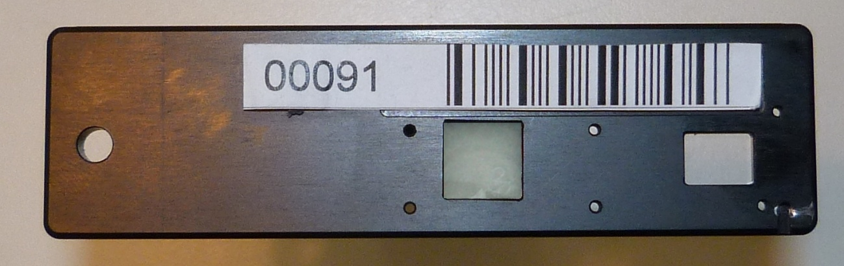

Figure 1: The reverse side of the MEMORI dosimeter with the barcode and identity number, and the sensitive GSD glass (left) and EWO polymer/glass (right) in their respective openings. The total length of the dosimeter is 9 cm.

2. The start measurement is performed by inserting the dosimeter into the slot on the front of the MEMORI reader (Figure 2) to the adjusted position. The insertion should be slow and gradual to assure smooth positioning. Operating information is obtained from three LED (Light Emitting Diodes) on the instrument front panel, for the measurements (M), for the battery (B) and for the clock (C).

When no measurements are performed (and the battery is charged) The M – LED always gives a low frequency blinking green **standby** light.

The M - LED will gives a blinking green light (high frequency) when the dosimeter is inserted and a solid green light when the dosimeter is fully inserted to the fixed measurement position and the measurement is ongoing.

The B - LED is blinking with a red light if the battery needs charging. The charging is performed by connecting the USB cable to a PC.

A blinking red light from the C - LED is a fault signal which shows that the clock needs adjustment, before a measurement can be performed. The clock is adjusted by connecting the instrument to a PC with the operating MEMORI software and clicking the adjustment button.

**End of measurement:** When the dosimeter has been measured, the M - LED will again change to give a blinking green light. Remove the dosimeter. The instrument will begin the reference measurement sequence and give a solid green light. When the whole measurement sequence is finished the M – LED goes into the standby mode. Insert another dosimeter only after the M – LED has turned into the standby mode.

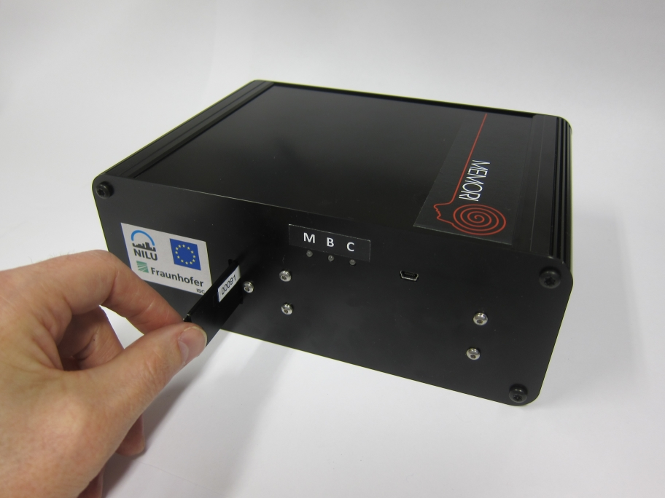

Figure 2: The portable MEMORI reader.

***LED signals:***

***Measurement, the M – LED:***

1. ***Wakeup:*** *When a dosimeter is half way inserted in the instrument the system wakes up. The measurement M - LED indicates with a blinking green light that the system is active. If the user does not proceed with the insertion of the dosimeter within 10 seconds the LED will give a blinking red light for 3 seconds and the system will go into a standby mode again (low frequency blinking green light). In this case the dosimeter has to be removed and inserted again.*
2. ***Sample ID:*** *When the dosimeter is fully inserted the Sample ID is read by the barcode reader. If the ID cannot be read in 2 attempts a fault is signaled with a blinking red light from the M - LED. When the sample ID has been recorded the measurement starts.*
3. ***Start measurement:*** *The dosimeter must be fully inserted and not be moved, to activate the measurement. A solid green light from the M - LED indicates that a measurement is ongoing. If the measurement is interrupted the M – LED gives a blinking red light to indicate a faulty measurement. In this case remove the dosimeter from the reader and reinsert it (see point 1).*
4. ***End of measurement:*** *When a measurement is finished the M – LED again changes to give a blinking green light. The user will now remove the dosimeter. When the dosimeter has been removed the M – LED will change to give a solid green light during the automatic reference measurement. When the whole measurement sequence is finished the M – LED turns into the standby mode. If another holder is inserted during the reference measurement or any other fault is occurring during the measurement sequence the M - LED will indicate a fault with a blinking red light. In this case remove the dosimeter from the reader and reinsert it (see point 1).*

***Battery charging, the B - LED:***

*The B - LED gives a blinking red light (or is off) if the battery needs charging.*

*The battery is charged when the reader is connected by the USB to a computer. (The instrument should not be connected to a computer during measurements)*

*During the charging the B – LED gives a solid green light.*

*The battery must be charged for the user to be able to do a measurement.*

***Clock, the C - LED:***

*The C - LED gives a blinking red light if the clock needs adjustment.*

*When the reader is connected by the USB cable to the PC which has the MEMORI software for the uploading of measurements installed, and the MEMORI software is started, the user has the option to set the clock to the PC time. If the instrument time is different from the PC time the user will be informed.*

*The clock must be set, by the provider of the instrument or user, before the first measurement with the instrument can be performed.*

1. The identity of the dosimeter (the identity number + the time, date and year of the start measurement) and the start value is stored in the memory of the reader.
2. Upload the start values to the PC which has the MEMORI software installed, via the USB cable, and then upload the start values and register the dosimeter location on the MEMORI web pages (see Part 2).
3. Mount the dosimeter on the location for the three months of exposure before demounting and doing the result measurement. (see the “Guidelines for the use of the MEMORI dosimeter”). Intermediate results measurements may be performed. All the measurement values should be uploaded to a PC and then to the MEMORI web pages (see Part 2).

## Part 2. Results display and presentation

***A. Install the MEMORI software on your local computer.***

The software is available for downloading from the MEMORI web page. To download the software the user must create and account and login on the results page (results tab). Click on the link to the software on the top of the results page. The software will be installed on your computer with a shortcut to an icon on your desktop.

**B. Uploading of measurement files to your local computer**

1. Connect the reader to your computer with the USB cable.
2. Open the MEMORI software and view the measurement files stored in the reader by double clicking on the MEMORI software icon.
3. Mark and save your files to your selected folder on your computer. The default folder is C:users\[username]\documents\MEMORI

**C. Uploading of measurement files from your local computer to the MEMORI web pages.**

1. Open the MEMORI web pages and log in as a “MEMORI dosimeter user” to your assigned results pages by inserting your username and password.
2. On the appearing results page no.1 (see Figure 3) select your MEMORI folder on the computer and mark and upload the result file(s).

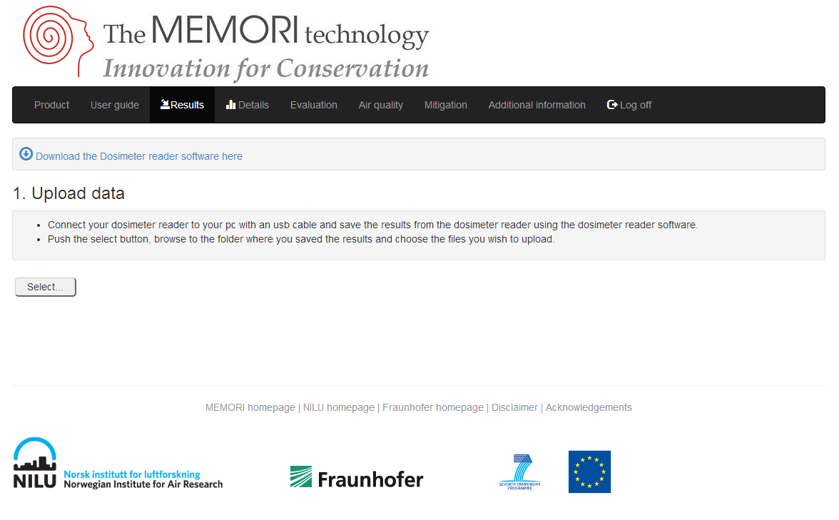

Figure 3: The MEMORI web page for uploading of results before the uploading of any results files.

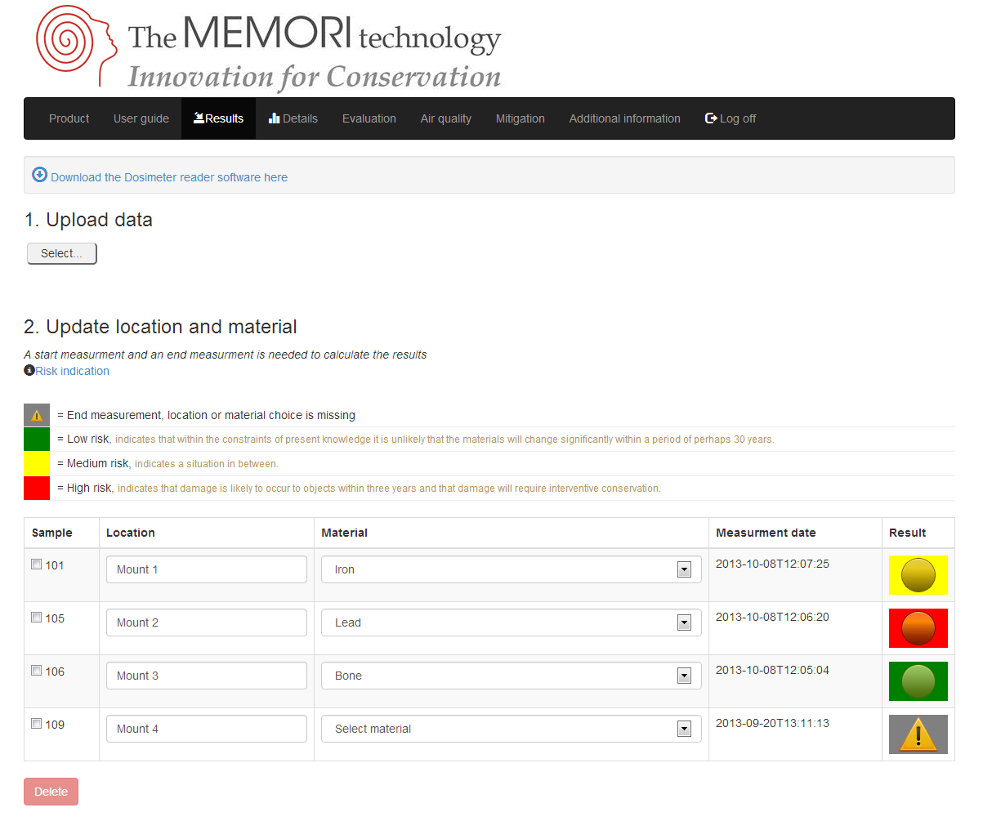

Figure 4: The MEMORI web page for uploading of results and easy “traffic light response” interpretation of uploaded results files.

1. A results line will appear (Figure 4) with the identity (bar code) number of the dosimeter and the time of measurement. Please write in a location description and chose a relevant material from the drop down menu.
2. If you do not write in the location description or chose a material, or your measurement is a start measurement a triangular mark will be visible to the right (see Figure 4).
3. If your measurement is an end measurement the results value for the dosimeter will appear and if you have written the location description and chosen a material a traffic light warning (green, yellow or red) will be visible to the right on the line (see Figure 4).

Green = Low risk for damage

Yellow = Medium risk for damage

Red = High risk for damage

1. If you click the traffic light warning or the “details” tab the results page no. 2 (see Figure 5) will appear. By selecting the time series (i.e. the dosimeter measurements) and materials of interest you can see a more detailed evaluation with your selected measurement points in an evaluation diagram (Figure 6), which displays the EWO value on the horizontal axis and the GSD value on the vertical axis. To see your selected results the materials of interest must be selected in the drop down menu.

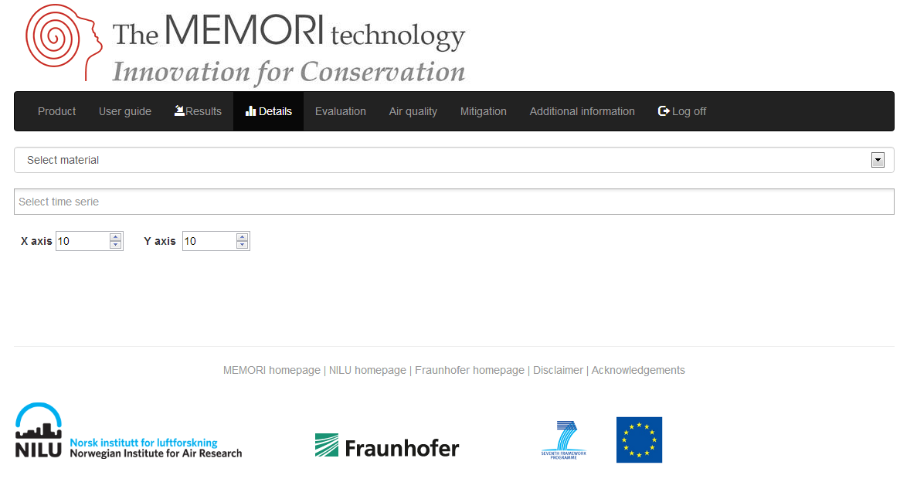

Figure 5: The MEMORI web page for detailed diagrammatic results interpretation before any time series and material(s) have been chosen.

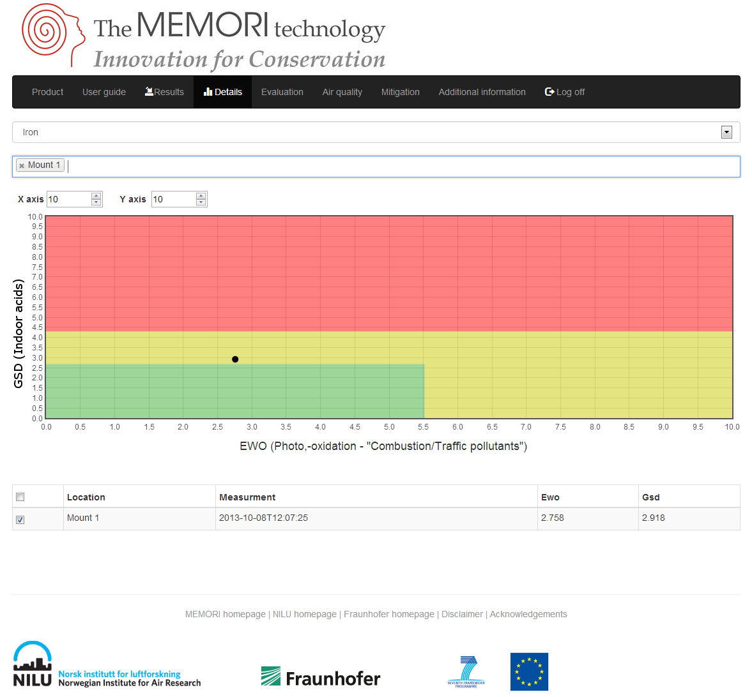

Figure 6: The MEMORI web page for detailed diagrammatic results interpretation with a time series and material chosen.

## Troubleshooting

1. **Contact with the MEMORI reader.** If a contact with from the computer to the MEMORI reader is not established upon connecting via USB, the device manager on the computer should be opened:

- Right click on “Computer”

- Left click on “Properties”

You should now be in:

Control Panel\System and Security\System

* Left click on “device manager” (You may need to have administrator rights to make changes)

If you get an information dialog box then click “OK”

* Go to /ports(COM & LPT) and expand

Look for the USB Serial Port (Communications Port)

* Note the named COM port (e.g. COM1, COM2 etc.)
* Write the “COM#” into the “Specify the COM Port (exCOM2)” window
* Press the connect button.

If the reader is connected and there is an “Unknown device” under the “Other devices” node then windows might be missing the driver. You can confirm this by unplugging the reader and the “Unknown device” will disappear.

The missing driver can be downloaded to your computer from <http://memori.nilu.no/download/CDM%20v2.12.00%20WHQL%20Certified.zip>. - - Unzip archive, run the executable and follow the instructions.

- Plug in the reader and it should now appear in the “Ports (COM & LPT)” node.

- Restart the MEMORI software

2. **Web browsers.** The MEMORI results web presentation system has been tested with the web browsers: Internett explorer v9 and v10 and Google Chrome. If you experience some malfunctioning in the results presentation with other web browsers you should install, change to one of these web browsers.